

Vth Semester B. Tech Data Science & Engineering DSE 3141 Deep Learning Lab [0 0 3 1]

LABORATORY MANUAL

Instructors:
Dr. Rohini R Rao,
Dr. Abhilash K Pai,
Dr. Gangothri

Department of Data Science & Computer Applications
Manipal Institute of Technology, Manipal, India

JULY 2025
COURSE OUTCOMES (COS)
At the end of this course, the student should be able to:
 |  |  | No. of  Contact  Hours | Marks
CO1 | Apply the tools, on different dataset types, do performance evaluation methods, and fine-tuning strategies to build and optimize vanilla deep neural network models for performing classification and regression on structured data. | 6 |  | 15
CO2 | Design, develop, fine-tune, evaluate simple and advanced CNN models for Image classification. | 9 |  | 35
CO3 | Design, develop, fine-tune, evaluate simple and advanced RNN models for sequence modelling tasks like Time series prediction and NLP. | 12 |  | 35
CO4 | Design, develop, fine-tune, and evaluate Autoencoders and Generative models for representational learning. | 9 |  | 15
 | Total | 36 |  | 100

ASSESSMENT PLAN
Components |  | Continuous Evaluation | End semester Examination
Duration |  | 2.5 Hours per week | 180 Minutes
Weightage |  | 60% | 40%
Pattern | •  •  • | 1 evaluation of 20 marks:  - Record : 6M,  - Program execution : 7M,  - Quiz : 7M  1 Mid-Sem Examination: 20 marks  Mini Project : 20 marks  1. Phase1: Problem + Literature: 5M 2. Phase 2: End-to-End solution: 8M  3. Phase 3:Deployment & Demo: 7M | Model Performance Analysis:  15 marks,  Program execution : 25 marks.

LESSON PLAN
Week No | TOPICS | Course  Outcome  Addressed
Week 1 | Tensorflow & Keras Tutotial,  Getting Started with Building Fully Connected Neural Networks In  Keras | CO1
Week 2 | Experimenting with Deep Neural Networks | CO1
Week 3 | Convolutional Neural Networks (CNN) Vs Fully Connected Neural  Networks for Image Classification | CO2
Week 4 | Advanced CNN Architectures and Transfer Learning for Image  Classification | CO2
Week 5 | Recurrent Neural Networks for Time Series Forecasting | CO3
Week 6 | Mid-Semester Examination, Mini Project | CO2
Week 7 | LSTM and GRU for Sentiment Analysis | CO3
Week 8 | Neural Machine Translation using Encoder-Decoder Architecture, Mini Project Phase 2 evaluation | CO3
Week 9 | Image Reconstruction and Image Denoising Using Autoencoders, Image Generation Using Generative Adversarial Networks | CO3
Week 10 | Fine tuning of LLM for NLP tasks | CO4
Week 11 | Mini Project Final Evaluation | CO1
Week 12 | End-term lab examination

References:

SL.No | References
1 | Aurelien Geron, “Hands-On Machine Learning with Scikit-Learn, Keras & Tensorflow, OReilly Publications
2 | Francois Chollet, “Deep Learning with Python”, Manning Publications Co, 2nd edition
3 | Introduction to Tensorflow, https://www.tensorflow.org/learn
4 | Keras Documentation, https://keras.io/
5 | Ahmed Menshawy, Md. Rezaul Karim, Giancarlo Zaccone, “ Deep Learning with TensorFlow”, Packt Publishing

TENSORFLOW & KERAS TUTORIAL
1.1 What is TensorFlow?
TensorFlow is an open-source deep learning framework developed by the Google Brain team. It allows users to create, train, and deploy machine learning models, especially deep neural networks. TensorFlow provides a flexible architecture to work with numerical data using multi-dimensional arrays called tensors. It supports both CPU and GPU computations, making it suitable for running on a variety of hardware.
1.2 What are Tensors?
In TensorFlow, tensors are the fundamental data structures used for representing data. They are similar to multi-dimensional arrays and can hold data of any number of dimensions. Tensors are the building blocks of neural networks, as they store the input data, weights, biases, and intermediate outputs during the computation.
Examples of Tensors:
- Scalar (0-D tensor): A single value is a 0-D tensor.
Eg: scalar_tensor = 5 #rank-0 tensor
- Vector (1-D tensor): A 1-D tensor contains a sequence of values.
Eg: vector_tensor = [1, 2, 3, 4, 5] #rank-1 tensor
- Matrix (2-D tensor): A 2-D tensor is an array of arrays.
Eg: matrix_tensor = [[1, 2, 3], [4, 5, 6], [7, 8, 9]] #rank-2 tensor
- Higher-dimensional tensor (e.g., 3-D tensor):
Eg: tensor_3d = [[[1, 2], [3, 4]], [[5, 6], [7, 8]]] #rank-3 tensor
Note: For a detailed explanation, visit the TensorFlow | Tensor documentation:
https://www.tensorflow.org/guide/tensor
1. 3 Graph Computation:
TensorFlow follows a symbolic approach for computation using graphs. A graph is a computational graph that represents the flow of data through a series of operations (nodes) to produce output (tensors). The nodes in the graph represent operations, and the edges represent tensors flowing between these operations.
Example of Graph Computation:
import tensorflow as tf

# Define input variables (placeholders) x = tf.placeholder(tf.float32) y = tf.placeholder(tf.float32)

# Define operations
x_squared = tf.square(x) # Square operation
x_squared_times_y = tf.multiply(x_squared, y) # Multiply operation result = tf.add(x_squared_times_y, tf.add(y, 2)) # Add operation
# Create a session to run the computation graph with tf.Session() as sess:
# Provide input values and run the graph
output = sess.run(result, feed_dict={x: 3.0, y: 4.0}) print("Output:", output)

Fig1: Computation graph in tensorflow for 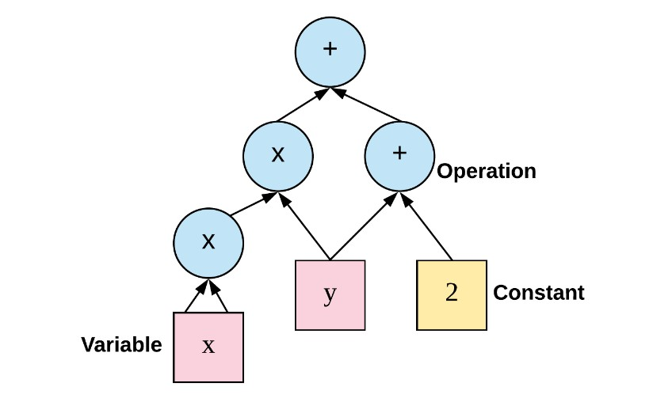f(x, y) = x y + y + 2
2
[Image Source: https://iq.opengenus.org ]

1.4 What is Keras?
Keras is an open-source high-level neural networks API written in Python and capable of running on top of TensorFlow, among other backends. It was designed with a focus on enabling fast experimentation and easy-to-use syntax for building deep learning models. Keras provides a userfriendly interface for constructing complex neural networks, making it an ideal choice for beginners in deep learning.
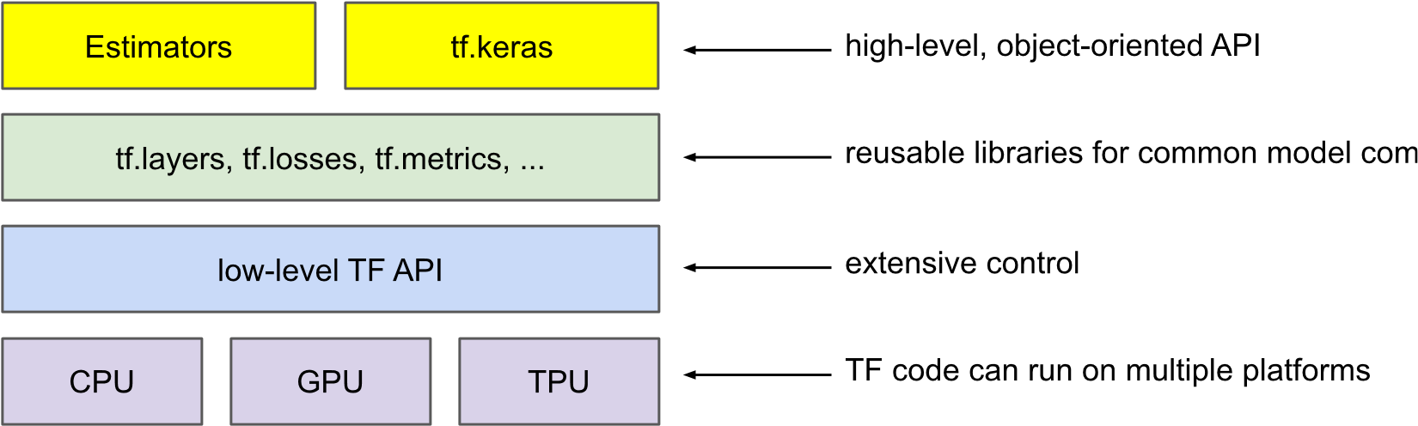

Fig 2. Tensorflow and Keras as API
Image Source: https://developers.google.com/
Note: For a detailed explanation, visit the TensorFlow | Keras documentation: https://www.tensorflow.org/guide/keras

In Keras, there are two primary ways to create deep learning models: the Sequential API and the Functional API. Each approach serves a different purpose and offers distinct advantages.
1.5 Sequential API:
The Sequential API is the simplest and most straightforward way to build deep learning models in Keras. It allows you to create a linear stack of layers, where each layer has exactly one input tensor and one output tensor. This means that the data flows sequentially through each layer in the order they are added to the model. The Sequential API is well-suited for simple feedforward neural networks and other models that have a clear linear flow of data.
Example of Sequential API:
from keras.models import Sequential from keras.layers import Dense, Input

# Create a sequential model model = Sequential()

# Add layers to the model model.add(Input(shape=(input_dim,))) model.add(Dense(64, activation='relu')) model.add(Dense(32, activation='relu')) model.add(Dense(10, activation='softmax'))

# Compile the model

model.compile(optimizer='adam', loss='categorical_crossentropy', metrics=['accuracy'])

# Print the model summary model.summary()

1.6 Functional API:
The Functional API in Keras allows you to create more complex models with multiple input and output tensors, as well as models with shared layers. It provides greater flexibility and is particularly useful when building models with branching or merging architectures.
Example of Functional API:
from keras.models import Model from keras.layers import Input, Dense

# Define input tensor
input_tensor = Input(shape=(input_dim,))

# Create layers and connect them
hidden_layer1 = Dense(64, activation='relu')(input_tensor) hidden_layer2 = Dense(32, activation='relu')(hidden_layer1) output_tensor = Dense(10, activation='softmax')(hidden_layer2)

# Create the model
model = Model(inputs=input_tensor, outputs=output_tensor)

# Compile the model

model.compile(optimizer='adam', loss='categorical_crossentropy', metrics=['accuracy'])

# Print the model summary model.summary()

1.7 Deep Learning Model Life-Cycle
The deep learning model life cycle typically involves the following steps: Define the model, Compile the model, Fit the model, Evaluate the model, and Make predictions. I. Define the Model:
In this step, you specify the architecture of your deep learning model. You define the layers, their configurations, activation functions, and any other required settings. The architecture depends on the problem you are trying to solve, and it may include fully connected layers, convolutional layers, recurrent layers, etc.
from keras.models import Sequential from keras.layers import Dense

# Define the model model = Sequential()
model.add(Dense(64, activation='relu', input_shape=(input_dim,)))
model.add(Dense(32, activation='relu')) model.add(Dense(10, activation='softmax'))

II. Compile the Model:
After defining the model, you need to compile it. During this step, you specify the loss function, optimizer, and evaluation metrics. The loss function is used to measure how well the model is performing on the training data. The optimizer determines how the model's weights are updated during training, and the evaluation metrics provide additional performance metrics during training.

# Compile the model

model.compile(optimizer='adam', loss='categorical_crossentropy', metrics=['accuracy'])

- Fit the Model:
In this step, you train the model on your training data. You provide the input features (X) and their corresponding target labels (y) to the model. The model then adjusts its internal parameters (weights) through an optimization process (usually gradient descent) to minimize the defined loss function.
# Fit the model
model.fit(X_train, y_train, epochs=10, batch_size=32, validation_data=(X_val, y_val))

- Evaluate the Model:
After the model is trained, you need to evaluate its performance on a separate set of data that it has never seen before (e.g., a validation set or a test set). This step gives you an indication of how well the model generalizes to unseen data.
# Evaluate the model
loss, accuracy = model.evaluate(X_test, y_test) print(f"Test loss: {loss}, Test accuracy: {accuracy}")

- Make Predictions:
Once the model is trained and evaluated, you can use it to make predictions on new, unseen data. You pass the new data to the model, and it will provide predictions based on what it has learned during training.
# Make predictions
predictions = model.predict(X_new_data)

Example: Building a Simple Neural Network with Keras

#1) Import the necessray libraries

import numpy as np import tensorflow as tf
from tensorflow.keras.models import Sequential from tensorflow.keras.layers import Dense, Input

#2) For the tutorial, lets experiment with random data

# Generate random input data (features)
X = np.random.rand(num_samples, num_features)

# Generate random output labels (classes)
y = np.random.randint(0, num_classes, size=num_samples)

# Split the data into training and testing sets split_ratio = 0.8
split_index = int(num_samples * split_ratio)

X_train, X_test = X[:split_index], X[split_index:] y_train, y_test = y[:split_index], y[split_index:]

#3) Define the model

# Build the neural network model using Sequential API model = Sequential([
Input(shape=(num_features,)),
Dense(6, activation='relu'), # Hidden layer with 6 neurons Dense(num_classes, activation='softmax') # Output layer with num_classes neurons and softmax activation for classification
])

# Display a summary of the model architecture model.summary()

#4) Compile the model

# Compile the model
model.compile(optimizer='adam', loss='sparse_categorical_crossentropy', metrics=['accuracy'])

#5) Fit/train the model

# Train the model using the training data epochs = 50 batch_size = 32
model.fit(X_train, y_train, epochs=epochs, batch_size=batch_size, validation_split=0.1)

#6) Evaluate/test the model

# Evaluate the model on the testing data
loss, accuracy = model.evaluate(X_test, y_test, batch_size=batch_size)
print("Test Loss:", loss) print("Test Accuracy:", accuracy)

WEEK-2: EXPERIMENTING WITH DEEP NEURAL NETWORKS
Q1. Consider the following dataset ‘Churn_Modelling.csv’:
https://www.kaggle.com/datasets/aakash50897/churn-modellingcsv

The dataset has 14 features which are as follows :

- RowNumber:- Represents the number of rows
- CustomerId:- Represents customerId
- Surname:- Represents surname of the customer
- CreditScore:- Represents credit score of the customer
- Geography:- Represents the city to which customers belongs to
- Gender:- Represents Gender of the customer
- Age:- Represents age of the customer
- Tenure:- Represents tenure of the customer with a bank
- Balance:- Represents balance hold by the customer
- NumOfProducts:- Represents the number of bank services used by the customer
- HasCrCard:- Represents if a customer has a credit card or not
- IsActiveMember:- Represents if a customer is an active member or not
- EstimatedSalary:- Represents estimated salary of the customer
- Exited:- Represents if a customer is going to exit the bank or not.

- Perform the required pre-processing and write comment lines to explain the pre-processing steps.

- Perform experiments using (80,10,10) split and tabulate performance in terms of Accuracy, Precision & Recall for the following experimental setup:
  - Number of Hidden Layers and Number of Units per Layer

Number of Hidden Layers | Number of Units
1 | 128, 0 ,0
2 | 128, 64, 0
3 | 128, 64, 32

  - Epochs (10,20,30)
  - Activation function (Sigmoid, ReLU )
  - Without Regularization, with Regularization (L1/L2)
  - Learning rate (0.1, 0.01,0.001)
Visualize the training and validation loss against the epochs and comment on optimal hyperparameters.

Q2. Consider the following Boston Housing dataset — a well-known dataset used in housing value-to understand the effect of various hyperparameters and architectural changes on the performance of a neural network using the House Boat dataset.
Features in the dataset:
- CRIM: per capita crime rate by town
- ZN: proportion of residential land zoned for lots over 25,000 sq.ft.
- INDUS: proportion of non-retail business acres per town
- CHAS: Charles River dummy variable (= 1 if tract bounds river; 0 otherwise)
- NOX: nitric oxides concentration (air pollution)
- RM: average number of rooms per dwelling
- AGE: proportion of owner-occupied units built before 1940
- DIS: distances to five Boston employment centers
- RAD: accessibility to radial highways
- TAX: property tax rate per $10,000
- PTRATIO: pupil–teacher ratio by town
- B: 1000 × (Bk – 0.63)² where Bk is the proportion of Black residents
- LSTAT: % of lower status population
- MEDV: Target – Median value of owner-occupied homes (in $1000s)

Build a neural network to predict the median house value (MEDV) using the above features.

Use the following hyperparameters/design choices for your neural network:
- Split the data in the ratio Training: Validation: Testing = 80:10:10.
- Perform Normalization using Standard Scalar.
- Number of Hidden layers = 3 and number of units for each hidden layers are 128,64,32, respectively.
- Epochs (10,20,30)
- Activation function (Sigmoid, ReLU )
- Without Regularization, with Regularization (L1/L2)
- Learning rate (0.1, 0.01,0.001)
- Visualize the training and validation loss against the epochs and comment on optimal hyperparameters.

Q3. For Q1 and Q2, Interpret the results of “model.summary()”.

